1) Calories_consumed-> predict weight gained using calories consumed
2) Delivery_time -> Predict delivery time using sorting time
3) Emp_data -> Build a prediction model for Churn_out_rate
4) Salary_hike -> Build a prediction model for Salary_hike
Do the necessary transformations for input variables for getting better R^2 value for the model prepared.
1) Calories_consumed
Data:-
In this calories dataset,14 observation with calories consumed and weight gain.
EDA:-
Do a exploratory data analysis on both calories consumed and weight gain of the dataset.

Correlation analysis:-
we analyse correlation or linear relationship between output of column weight gain with Calories consumed.
Correlation for weight gain vs calories consumed is 0.946991.
so correlation is very high.

Linear Model:-
After analysing correlation technique,we do linear model between output with input Variables .Then we find R-square and Adjusted R-squared value
R-square for WeightGain vs Calories consumed :0.8968
Adjusted R-square for WeightGain vs Calories consumed :0.8882

RMSE:-
After completes the model,we find Root Mean Square Error.
RMSE value for WeightGain vs Calories consumed : 232.8335

Transformation Technique:-
Then we doing a transformation technique to find the high R square and adjusted R square values.for that we use lot of transformation techniques(sqrt,log,reciprocal..) Applied with input and outputs.

Sqrt technique with input:-
Correlation analysis:-
we analyse correlation or linear relationship between output of column weight gain with Square root of Calories consumed.
Correlation for weight gain vs Sqrt(calories) consumed is 0.9255962
so correlation is very high (positive).

Linear Model:-
After analysing correlation technique,we do linear model between output with input Variables .Then we find R-square and Adjusted R-squared value
R-square for WeightGain vs Sqrt(Calories) consumed : 0.8567
Adjusted R-square for WeightGain vs sqrt(Calories) consumed :0.8448

RMSE:-
After completes the model,we find Root Mean Square Error.
RMSE value for WeightGain vs Sqrt(Calories) consumed : 121.5

Log technique with input:-
Correlation analysis:-
we analyse correlation or linear relationship between output of column weight gain with log of Calories consumed.
Correlation for weight gain vs log(calories) consumed is 0.8987253
so correlation is very high.
Linear Model:-
After analysing correlation technique,we do linear model between output with input Variables .Then we find R-square and Adjusted R-squared value
R-square for WeightGain vs log(Calories) consumed :0.8077
Adjusted R-square for WeightGain vs log(Calories) consumed :0.7917

RMSE:-
After completes the model,we find Root Mean Square Error.
RMSE value for WeightGain vs log(Calories) consumed : 141.0054

Log technique with input variable with squared output:-
Correlation analysis:-
we analyse correlation or linear relationship between output of column weight gain with log of Calories consumed.
Correlation for log(calories)vs(weight*weight) consumed is 0.8249636
so correlation is very high.

Linear Model:-
After analysing correlation technique,we do linear model between output with input Variables .Then we find R-square and Adjusted R-squared value
R-square for log(calories)vs(weight*weight) consumed :0.8516
Adjusted R-square for log(calories)vs(weight*weight) consumed :0.8246

RMSE:-
After completes the model,we find Root Mean Square Error.
RMSE value for WeightGain vs log(Calories) consumed : 0.03137703

Sqrt technique with output:-
Correlation analysis:-
we analyse correlation or linear relationship between output of column weight gain with Square root of Calories consumed.
Correlation for calories vs Sqrt(weight gain) consumed is 0.9559736
so correlation is very high.

Linear Model:-
After analysing correlation technique,we do linear model between output with input Variables .Then we find R-square and Adjusted R-squared value
R-square for calories vs Sqrt(weight gain) consumed : 0.9139
Adjusted R-square for calories vs Sqrt(weight gain) consumed :0.9067

RMSE:-
After completes the model,we find Root Mean Square Error.
RMSE value for calories vs Sqrt(weight gain) consumed : 212.68

Prediction technique:-
I am get high R-square and Adjusted R-square values in Sqrt technique with output.(i.e.., calories vs sqrt(weight gain))
I will predict a future answers with these linear models with interval of predict.

Error:-
predicted model then we will applied with fitting a absolute for predicted result
then finding a error associated with these absolute value and output(weight).

RMSE:-
find the error then we applied with RMSE technique to finds the Rmse values
rmse value is 2018.756

Plotting a graph between Absolute value vs Error:-
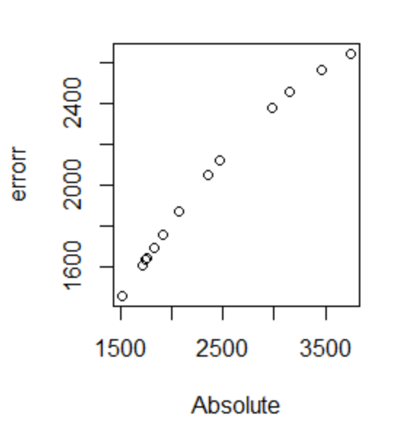

R-code:-
new=read.csv(file.choose())
names(new)[1]="weight"
names(new)[2]="calories"
new
attach(new)
library(lattice)
dotplot(weight,main="Dotplot for grams")
dotplot(calories,main="dotplot for calories")
boxplot(weight)
boxplot(calories)
hist(weight)
hist(calories)
qqnorm(weight)
qqline(weight)
qqnorm(calories)
qqline(calories)
hist(weight)
lines(density(weight))
lines(density(weight,adjust=2))
hist(calories)
lines(density(calories))
lines(density(calories,adjust=2))
plot(weight,calories)
attach(new)

cor(weight,calories)#0.946991(Positive correlation)
regg<-lm(calories~weight)
summary(regg)#R=0.8968,Adjusted R-squared: 0.8882
sqrt(sum(regg$residuals^2)/nrow(new))#232.8335

##############Transformation technique#####
##output with square of input variable###
cor(weight,sqrt(calories)) #0.9255962 (Positive correlation)
regg_sqrt<-lm(weight~sqrt(calories),data=new)
summary(regg_sqrt)#R= 0.8567 Adjusted R-squared: 0.8448
sqrt(sum(regg_sqrt$residuals^2)/nrow(new))#121.71

##############Transformation technique#####
##output with log of input variable###
cor(weight,log(calories))#0.8987253(Positive correlation)
regg_log<-lm(weight~log(calories),data=new)
summary(regg_log)#R=0.8077,Adjusted R-squared: 0.7917
sqrt(sum(regg_log$residuals^2)/nrow(new))#141.0054

##############Transformation technique#####
##output square with log of input variable###
cor(log(calories),weight*weight)#0.8249636
reg11<-lm(log(calories)~weight+I(weight*weight),data = new)
summary(reg11)#R=0.8516,Adjusted R-squared:0.8246
sqrt(sum(reg11$residuals^2))/nrow(new)#0.03137703

##Square of output with input variable###
cor(calories,sqrt(weight))#0.9559736
regg_sqrt1=lm(calories~sqrt(weight),data=new)
summary(regg_sqrt1) #R=0.9139,Adjusted R-squared:0.9067
sqrt(sum(regg_sqrt1$residuals^2)/nrow(new))#212.68
###Prediction model for high R & adjusted R value ####
pred6=as.data.frame(predict(regg_sqrt1,interval="predict"))
Absolute=abs(pred6$fit)
errorr=Absolute-new$weight#with output
sqrt(sum(errorr^2)/nrow(new))#2018.756
plot(Absolute,errorr)

##log of output with input variable###
cor(log(weight),calories)#0.936
regg_log1=lm(log(weight)~calories,data=new)
summary(regg_log1)#R=0.877,Adjusted R-squared: 0.8674

